**SODA ASH**

**HERO**

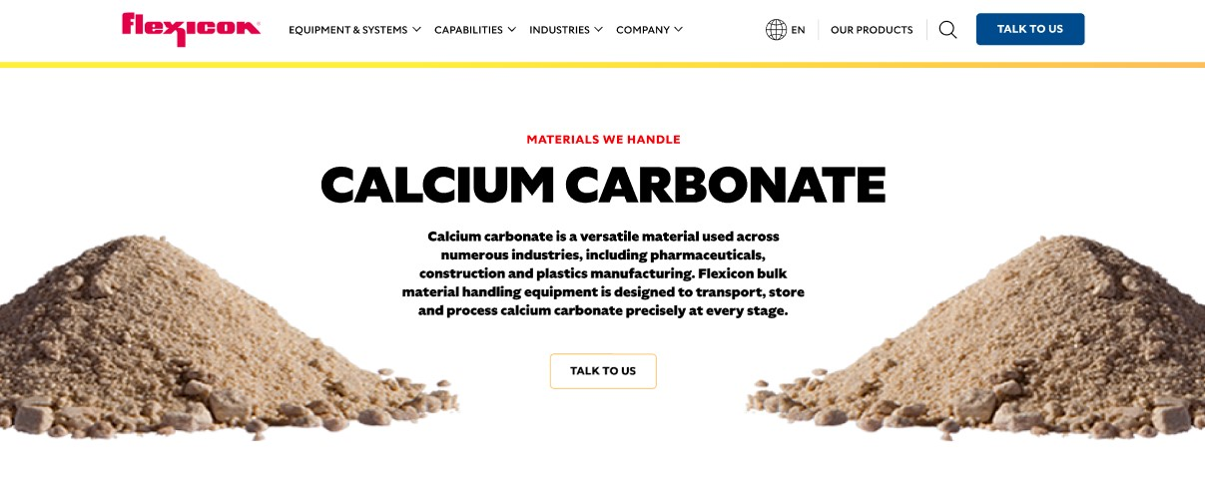

Soda ash is a key industrial material used in glass, chemical, and detergent manufacturing. Flexicon bulk material handling systems are built to handle soda ash with precision, ensuring safe and efficient movement, storage, and processing throughout your operation.

**Button**: Talk To Us

**SHELF #1 - PRODUCT DESCRIPTION**

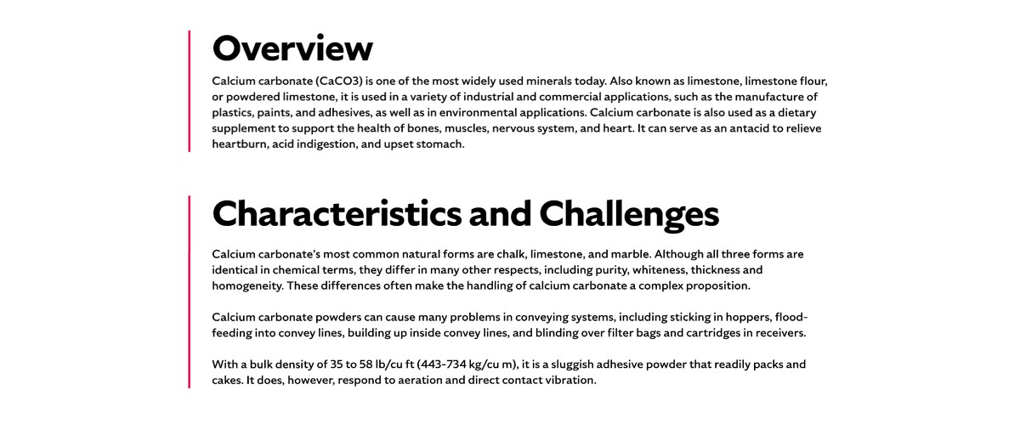

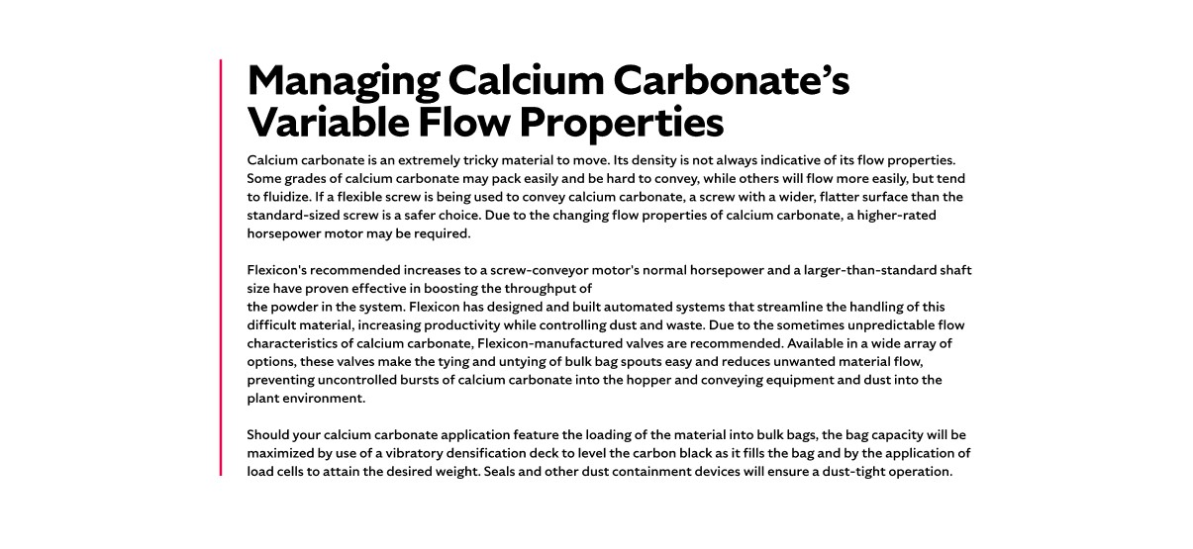

**Overview**Also known as sodium carbonate or washing soda by it’s chemical symbol Na2CO3, soda ash plays a vital role in industries such as glassmaking, paper production, and chemical processing. Nearly half of the soda ash produced in the U.S. is used in glass manufacturing, with additional applications in detergents and textiles. It is derived from natural sources like trona or brines and can also be produced synthetically via the Solvay method. Soda ash production is often viewed as an indicator of economic activity due to its widespread industrial use.

**Characteristics and Challenges**

Soda ash is typically a free-flowing, granular material that may be mildly abrasive. It is produced in three grades—light, medium, and dense—which share the same chemical composition but differ in bulk density, particle size, and shape, all of which affect flow behavior. When pneumatically conveyed, soda ash requires a properly sized blower to maintain optimal air velocity and prevent material degradation. Bulk bags containing soda ash should be discharged using frames equipped with spring-loaded supports and bag-activating devices to ensure complete emptying and promote consistent flow. These devices also help form a dust-tight seal between the bag and receiving hopper, minimizing airborne particles. Because soda ash dust is an eye and lung irritant, dust collection systems with filtration and pulse-cleaning features are essential to maintain a safe and clean environment.

In hoppers, coarser soda ash particles may interlock and obstruct flow, requiring mechanical agitators or vibrators to restore movement. For smaller bag packaging, bag dump stations with dust hoods and filtration systems support safe manual unloading, while integrated bag compactors allow for clean disposal of empty bags. Hopper screens help prevent contamination and protect operators during manual dumping. When using flexible screw conveyors, selecting a screw with a round profile helps move soda ash efficiently without damaging the material or separating fine particles. For bulk bag filling, densification decks and load cells ensure accurate weight and dust-free operation

**SHELF #2 - FLEXICON SOLUTIONS**

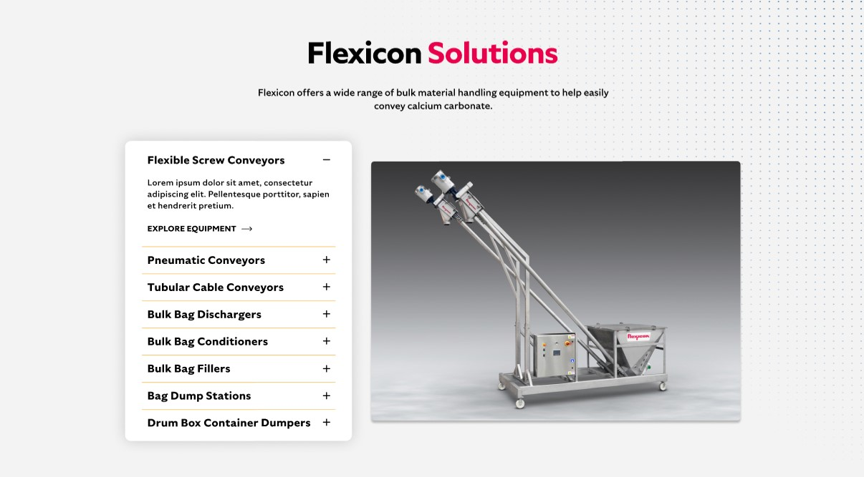

**Flexicon Solutions**

Flexicon offers a wide range of bulk material handling equipment to help easily convey soda ash:

**Flexible Screw Conveyors:** Effectively transport soda ash with screw configurations tailored to its granular and free-flowing nature.

**Pneumatic Conveyors:** Deliver soda ash through sealed systems that control dust and regulate airflow to prevent degradation.

**Tubular Cable Conveyors:** Move soda ash through enclosed, compact pathways ideal for tight plant layouts and contamination-sensitive processes.

**Bulk Bag Dischargers:** Ensure complete and clean discharge of soda ash from bulk bags using secure containment and flow-enhancing features.

**Bulk Bag Conditioners:** Restore flowability by softening hardened soda ash inside bulk bags prior to processing.

**Bulk Bag Fillers:** Load soda ash into bulk bags with precision, minimizing dust and achieving accurate fill weights.

**Bag Dump Stations:** Enable safe manual handling of soda ash with integrated dust control and ergonomic access.

**Drum/Box/Container Dumpers:** Transfer soda ash from smaller containers into processing systems with reduced dust and minimal operator strain.

**SHELF #3: LIFETIME PERFORMANCE GUARANTEE**

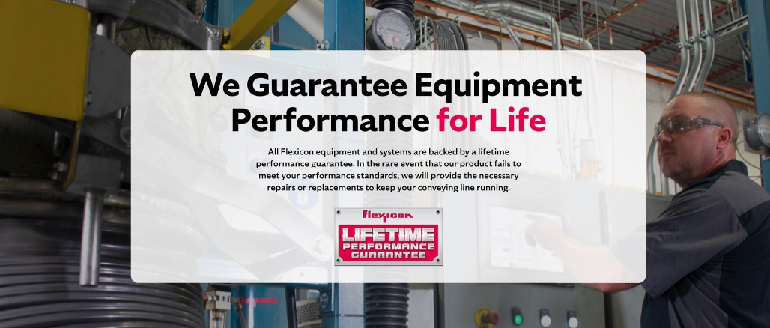

**Lifetime Performance Guarantee**

All Flexicon equipment and systems are backed by a lifetime performance guarantee. In the rare event that our product fails to meet your performance standards, we will provide the necessary repairs or replacements to keep your conveying line running.

**SHELF #4: CASE STUDIES**

